REPORT
on the Analyses performed in the frame of the Stardust Proposal:

LANDS
Laboratory ANalyses of Dust from Space

Combined non destructive analytical techniques
applied to 81P/Wild 2 samples after PET:
grains from the STARDUST track C2103,10

PI: A. Rotundi¹
Co-PI: J. Borg²

Co-Is: G.A. Baratta³, J.R. Brucato⁴, R. Brunetto^{1*},
L. Colangeli⁵, E. Dartois², V. Della Corte¹, L. d’Hendecourt², Z. Djouadi²,
V. Mennella⁵, M.E. Palumbo³, P. Palumbo¹.

¹ Dip. Scienze Applicate, Università degli Studi di Napoli “Parthenope”, Napoli 80134 ITALY
² Institut d’Astrophysique Spatiale (IAS), CNRS, Université Paris-Sud, UMR8617, F-91405 Orsay-Cedex, FRANCE
³ INAF - Osservatorio Astrofisico di Catania, Via Santa Sofia 78, 95123 Catania ITALY
⁴ INAF - Osservatorio Astrofisico di Arcetri, L.go E. Fermi 5, 50125 Firenze, ITALY
⁵ INAF - Osservatorio Astronomico di Capodimonte, Via Moiariello 16, 80131 Napoli ITALY

*Note: Co-investigator F. Grossemy has been replaced by co-investigator R. Brunetto.

LABORATORIES INVOLVED:
Laboratorio di Fisica Cosmica e Planetologia (LFCP), Naples, Italy
Laboratorio Astrofisica Sperimentale (LASp), Catania, Italy
Institut d’Astrophysique Spatiale (IAS), Orsay, France

This is a multidisciplinary project concerning the morphological, chemical, mineralogical and organic characterization of 81P/Wild 2 dust samples in line with the activity we performed as part of the Preliminary Examination Team effort.
We received and analysed ten grains from the Stardust track C2103,10 (i.e. samples #C2103,10,143,1∼10,0) using different non destructive techniques that give indications both on the mineralogical and organic compositions of the particles (IR and Raman spectroscopy combined to FESEM and EDX). These grains have been extracted from different positions along the track, between the entrance and the terminal particle. Aerogel fragments originating from the same keystone were also analysed with the same techniques. The aim was to obtain morphological, chemical, mineralogical, and organic characterizations of 81P/Wild 2 dust samples taking into account the slowing down evolution, fragmentation and interaction with the aerogel of the incident grain.
In order to avoid handling and micromanipulation of the samples, we designed special sample holders [1] that allow clean and safe particle transportation and multiple sample analyses. We performed a combined set of micro-InfraRed (IR) spectroscopy (transmission), micro-Raman, Field Emission Scanning Electron Microscope (FESEM), and Energy Dispersive X-ray (EDX) analyses. The IR analysis was performed using a synchrotron beamline at SOLEIL (France), which allows to map the samples with a spatial resolution up to ~3 µm, and a conventional globar type IR source (Naples), on the bulk grain, which was used also to check for any possible modification the grains could experience. Raman spectroscopy, a technique complementary to IR spectroscopy and sensitive to the carbon backbone structure and to its degree of order (e.g. [2, 3]), is performed using a 514.5 nm argon laser with power on the samples lower than 40 W/mm².
The IR analysis of the cometary grains and the nearby aerogel samples showed relevant contribution of the aerogel in the spectra of these extraterrestrial grains, as already largely observed (e.g. [4, 5]). Melted or compressed aerogel, due to the grain slowing down process, is strongly mixed with the residues of the incident particles; the effect is more pronounced with respect to other Stardust tracks previously studied by PET analyses [5]. Two grains, extracted close to the entrance and the termination of the track, show clear IR organic signatures, due to aromatic and aliphatic compounds respectively. Silicates are detected in one grain extracted from the end of the track, both in the mid- and far-IR, mainly in the form of amorphous low-Fe olivine (forsterite), with a minor contribution of crystalline olivine and pyroxene, as pictured in Fig 1.

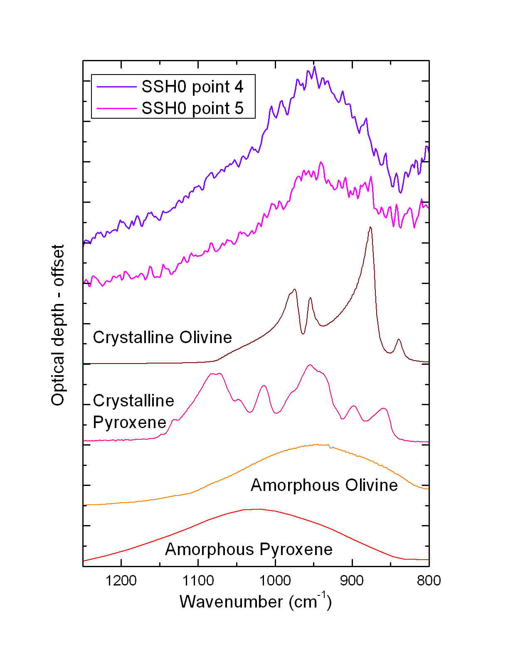
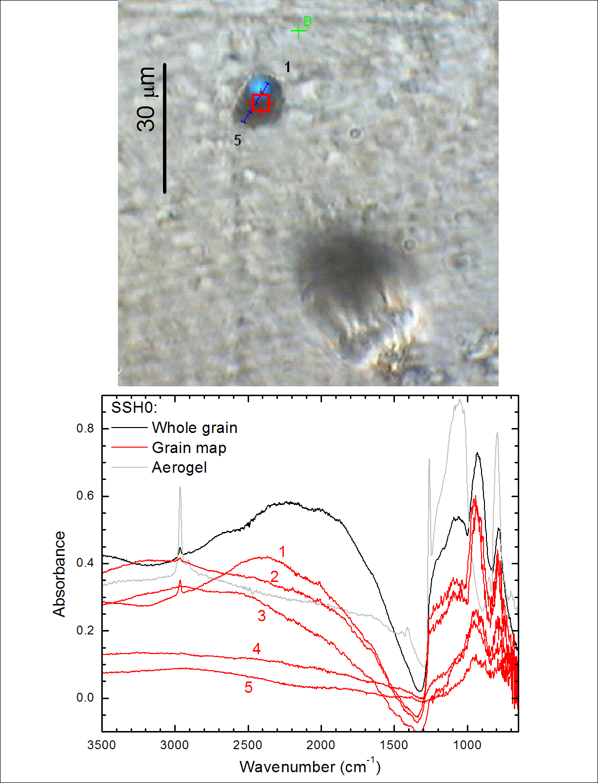
Fig. 1. Left: IR absorbance spectra (bottom) acquired for 5 positions (red lines) across the grain C2103,10,143,1,0 deposited on the SSH0 substrate (top), compared to the spectra of the whole grain (black line) and of a piece of aerogel (gray line). Relevant aerogel signatures are observed in spectra 1 and 2, while they are absent in spectra 4 and 5. Right: the aerogel-free spectra are compared with four laboratory spectra of crystalline and amorphous silicates, showing the presence of the amorphous olivine 10-µm feature in the cometary grain.

Amorphous carbon is detected in almost all grains thanks to micro-Raman spectroscopy. The characteristic G-band and D-band are observed, with a relatively high value of the G-peak position and of the G-FWHM (see Fig. 2). Different grains along the track exhibit different degrees of order of the carbon backbone structure.

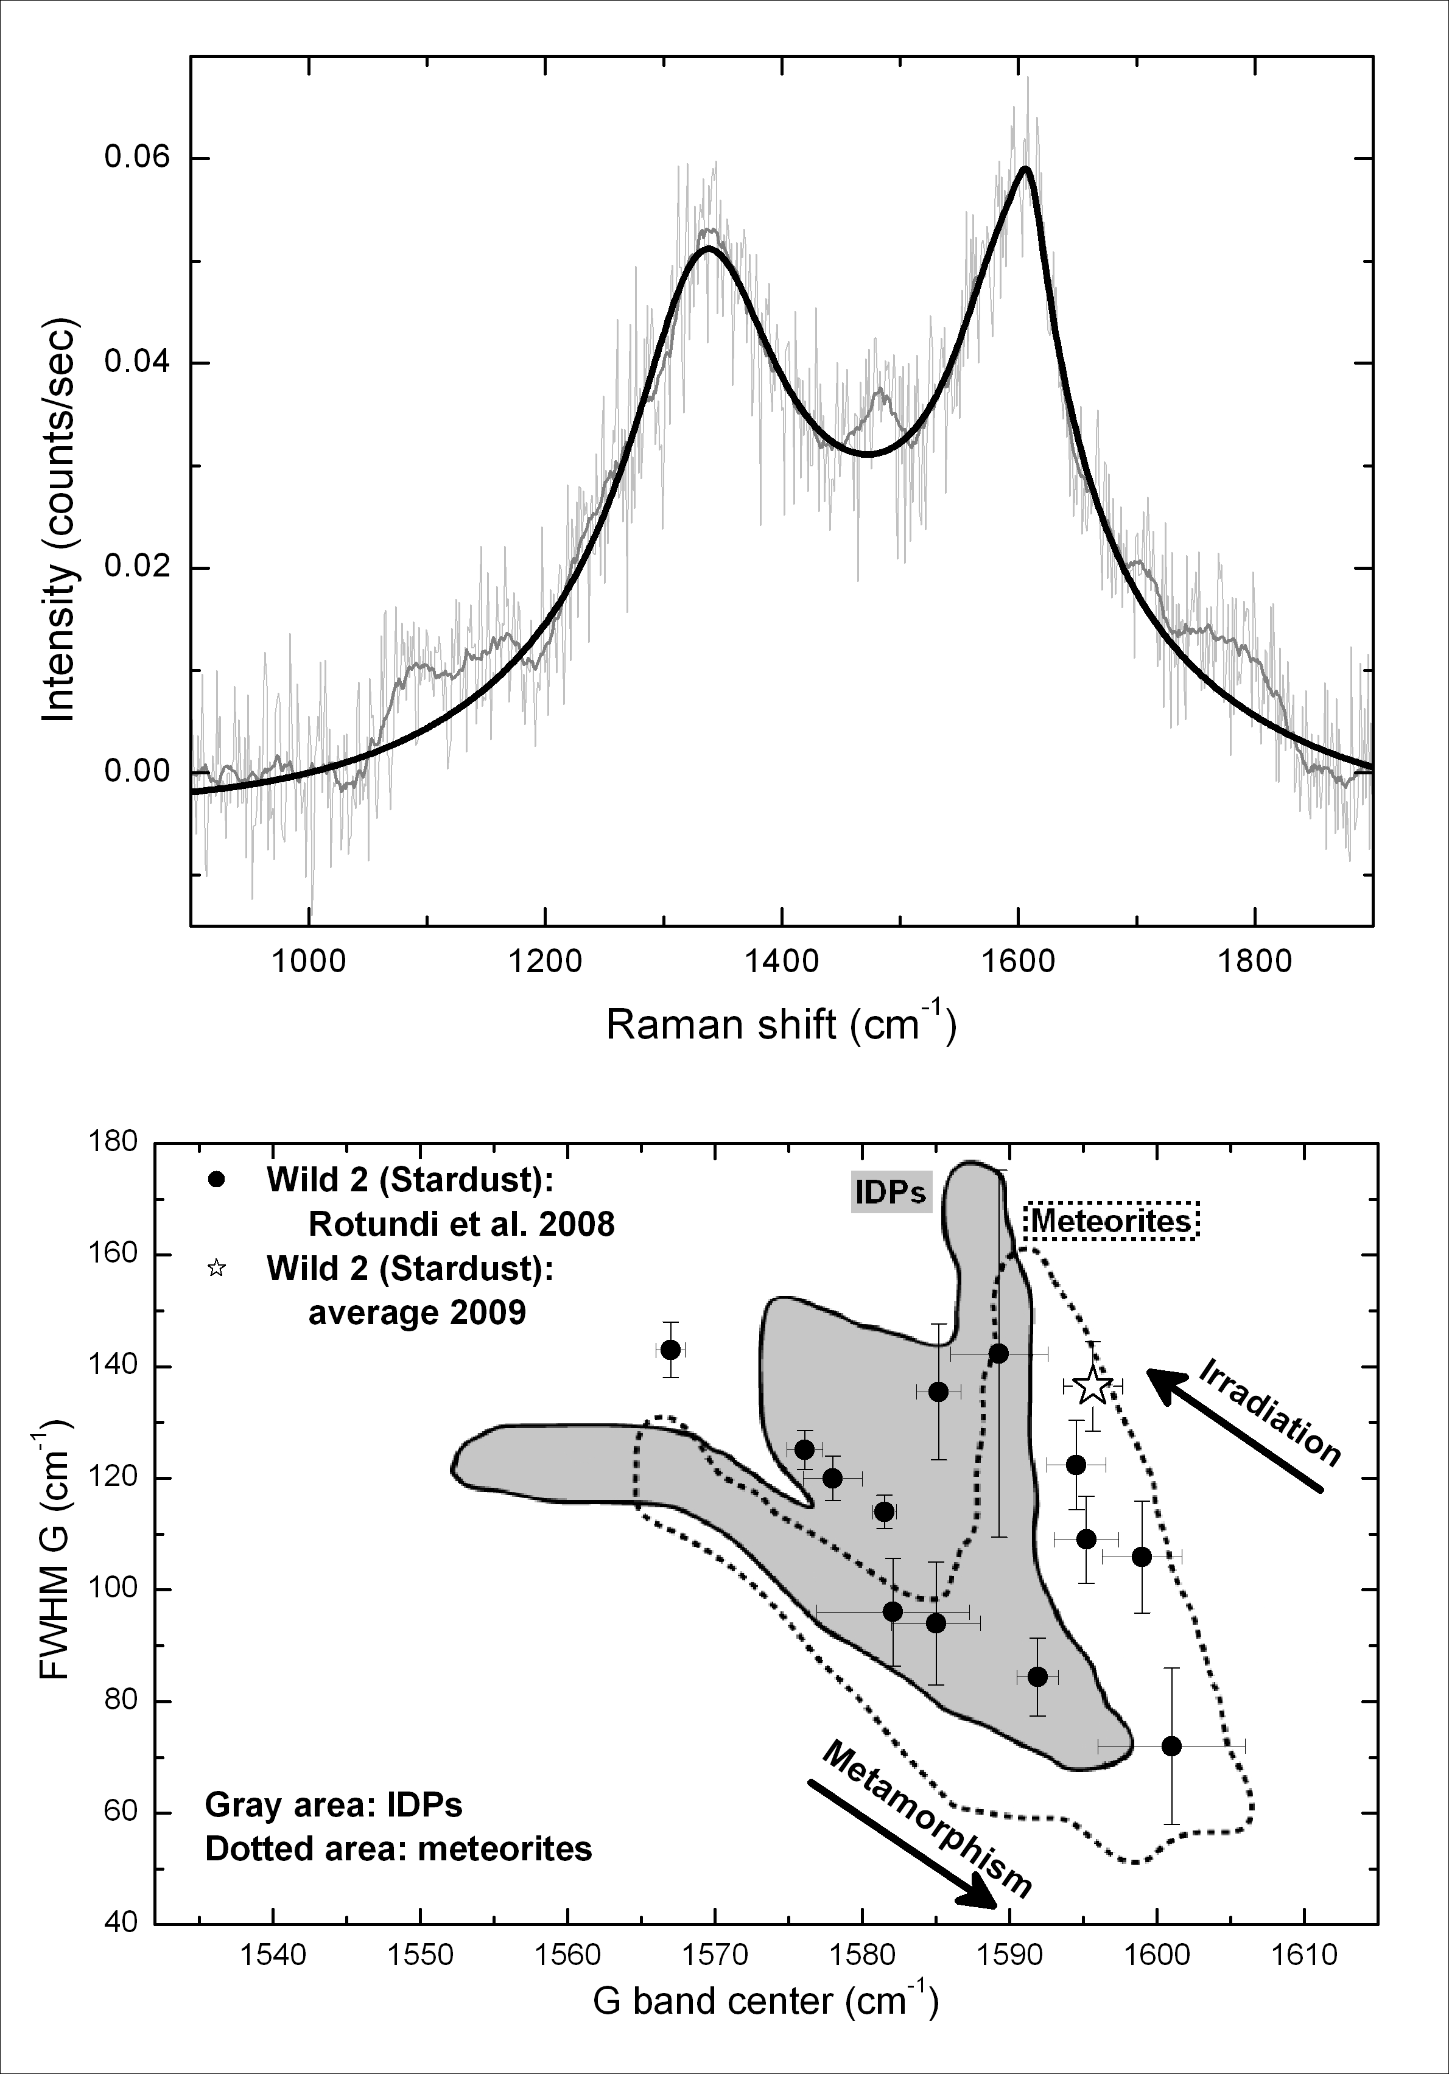
Fig. 2. Top: the average Raman spectrum of track C2103,10 Stardust grains is fitted using a 5 band-fit as described by Brunetto et al. (2009); similar results are obtained using a simplified fit (e.g. Gaussian, Lorentzian, or Breit-Wigner-Fano (BWF) 2-band fit curves). Bottom: G band full width at half maximum (FWHM) as a function of G band peak position, for IDPs, carbonaceous meteorites, and grains from comet Wild 2 collected by the NASA Stardust mission. Values for 40 IDPs and more than 40 meteorites are taken from Sandford et al., 2006 and references therein, values for 13 Wild 2 grains analyzed by PET are taken from Rotundi et al., 2008. Arrows mark the evolutionary path due to ion irradiation and the opposite trend due to metamorphism.

The IR and Raman analyses were followed by electron microscopy investigation (FESEM and EDX) delivering complementary information about the grains composition. EDX analyses was performed only on 6 grains due to sample charging. Results from EDX confirm the presence of Mg- and Fe- silicates and a relevant aerogel contribution. Iron and sulphur are present in some particles.

Acknowledgements
We are grateful to K. Nakamura-Messenger and to the Stardust Sample Curation Team. This Research has been supported by the Italian Space Agency, Università “Parthenope” di Napoli, INAF, MiUR, Regione Campania, the French “Agence Nationale de la Recherche”, and the French Space Agency CNES.

References
[1] Rotundi, A., et al. 2007, In Dust in planetary systems, ESA Publication SP-643. pp. 149–153.
[2] Baratta, G.A., et al. 2004. J. Raman Spectrosc. 35, 487–496.
[3] Brunetto, R., et al., 2009. Icarus 200, 323–337.
[4] Muñoz Caro, G. M., et al. 2008. A&A 485, 743–751.
[5] Rotundi, A., et al. 2008. Meteorit. Planet. Sci. 43 (1/2), 367–397.

